**MINAHIL QADIR**

**BSAI-3A(047)**

**TASK 4:**

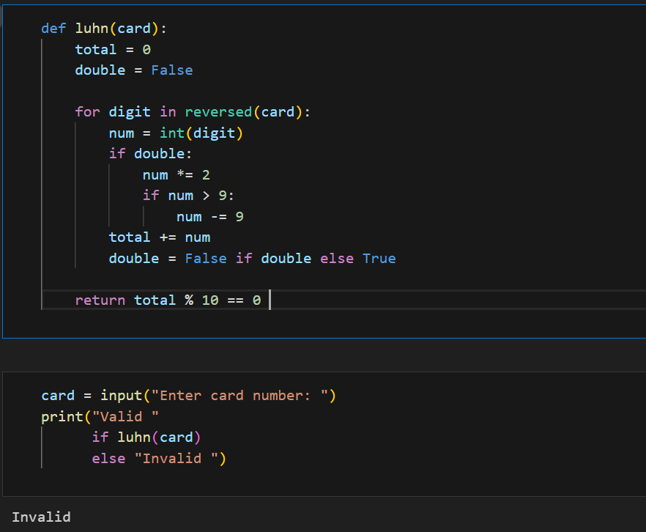

The Luhn algorithm checks if a credit card number is valid.

Reads the card number as input.

Processes digits from right to left, doubling every second digit.

If doubling makes it greater than 9, subtract 9.

Sums all digits and checks if the total is divisible by 10.

Prints "Valid" if the card number passes the check, otherwise "Invalid".

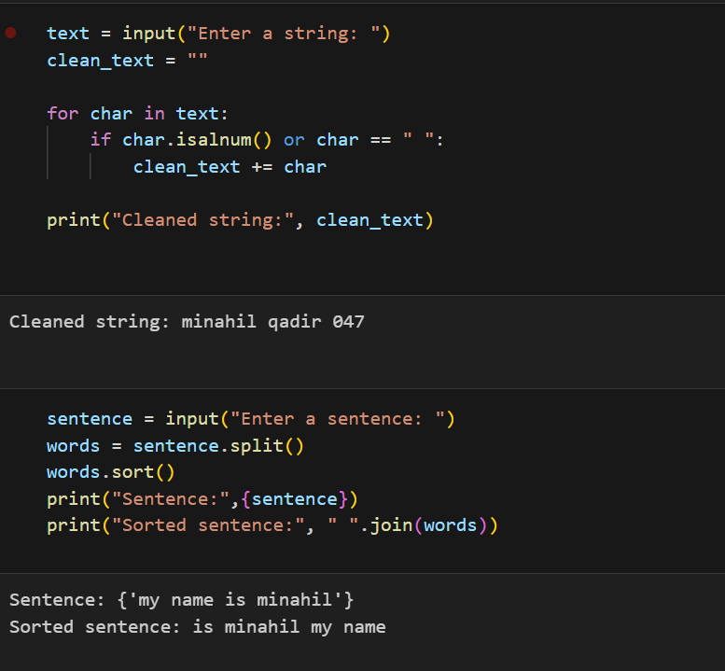

1:The program removes special characters from a user-inputted string while keeping letters, numbers, and spaces.

Takes input from the user.

Creates an empty string to store the cleaned text.

Loops through each character in the input:

If it's a letter, number, or space, it gets added to clean_text.

Prints the cleaned string without special characters.

2:This program sorts the words in a sentence alphabetically.

Takes a sentence as input from the user.

Splits the sentence into words using split().

Sorts the words in alphabetical order.

Prints the original sentence and the sorted sentence with words rearranged